

**Senior Design Project**

**The Design of a Virtual Reality Game for STEM Education**

ENGE476 Senior Design Project I

Department of Engineering and Aviation Sciences

University of Maryland, Eastern Shore

Tyler Gantz

Project Advisor, Dr. Lei Zhang

Submitted

December 7th, 2018

List of Contents

List of Figures 3

Abstract 4

1. Introduction 5

1.1 Backgound/Motivation 6

1.2 Objective 6

1.3 Design Requirements 6

1.4 Design Constraints 6

1.5 Design Methods 6

2. Implementation Plan 7

2.2 Timeline/Milestones/Delivery Plan 7

3. Implementation 8

3.1 Implementation of Task 1. 8

3.2 Implementation of Task 2. 9

3.3 Implementation of Task3. 11

4. Conclusion. 15

Acknowledgement 16

Appendix 17

REFERENCES 19

List of Figures

Figure 1. Game-Based Learning Logo 5

Figure 2. First Call of Duty vs. Newest Call of Duty: Growth of Technology in Visuals 5

Figure 3. Versatility in Implementation of Virtual Reality 6

Figure 4. Illustration of the different elements game--based learning incorporates 6

Figure 5. Flow diagram displaying the design approach 7

Figure 6. Project Timeline 9

Figure 7. Unity Logo 10

Figure 8. Unreal Engine Logo 10

Figure 9. Scene used during engine configuration 10

Figure 10. Picture supporting the proposed alien spaceship setting 11

Figure 11. Gameplay flow diagram 11

Figure 12. Examples of some assets found in the game 12

Figure 13. SteamVR Objects 13

Figure 14. Code for the body collider object script 13

Figure 15. Picture of the in-game hand models 14

Figure 16. Picture in each lens vs. Perceived image 14

Figure 17. Picture of a single floor piece 15

Figure 18. Overview of the entire room 16

Figure 19. LCD Screen object 16

Figure 20. Cover screen, question screen, and correct screen. 17

Figure 21. View of Multiple-Choice Question Buttons, and full-screen object view 18

Figure 22. Picture of some of the keys found in the game 19

Figure 23. Hologram found next to Question 1 19

Figure 24. Multiple Choice Key Slot and Associated Code 20

Figure 25. Battery used for circuit design objectives 20

Figure 26. A 5700 Ohm Resistor 21

Figure 27. Battery port 21

Figure 28. Example of the wiring and resistor ports 22

Figure 29. Energy shield examples 23

Abstract

By the end of the project, summarize the project into short text and put here.

1. Introduction

## Background/Motivation

From the beginning of any engineering program, students are required to take difficult courses that involve new math and physics concepts. From experience, this can be overwhelming, as a lot of these concepts are foreign both mathematically and mentally. Visualizing topics such as circuit configurations or truss problems in statics are not always intuitive to new students.

As it stands, the standard curriculum for engineering students at UMES consists of just lectures with a handful of labs included in a four-year degree program. While this proves to be successful for most students, more learning tools are always welcome. Now, what if those learning tools broke away from the monotony of the typical lecture, where students sit quietly and take notes, with the only interaction being asking questions to a professor. What if they provided an alternative to a lab, which typically only has students flipping a switch, measuring a value, then flip another switch, measure that value. In other words, what if there was a learning tool available to students that is both fun and interactive, but still educational.

This is where game-based learning comes in. Game-based learning, or GBL, uses competitive exercises, either pitting students against each other or getting them to challenge themselves in order to motivate them to learn better. Incorporating GBL into a curriculum has shown to motivate students to learn and, in turn, learn more effectively. Games provide an element of fantasy to the players, something that is not present in the typical lecture or lab. This element is what provides a fun and memorable experience for the students playing, which is what makes this approach to education so effective. [1]

Figure 1. Game-Based Learning Logo

Technology in gaming has come a long way since its beginning back in the ’80s. Visually, games have evolved from the 8-bit, pixelated graphics to the stunning 4K graphics found in games today. The way the players control and play their games has also evolved from using simple game 8 button gamepads to full motion controls. However, there is one innovation that stands out among the rest, and that’s virtual reality (VR). Especially in recent years, VR has become a prominent part of gaming with the release of popular hardware, like the HTC Vive and the Oculus Rift. Gaming platforms, such as PlayStation, Steam, and various mobile applications all offer VR support with compatible hardware. Having this technology at our disposal is great, but is it really that vital to incorporate it rather than just developing a simple video game? 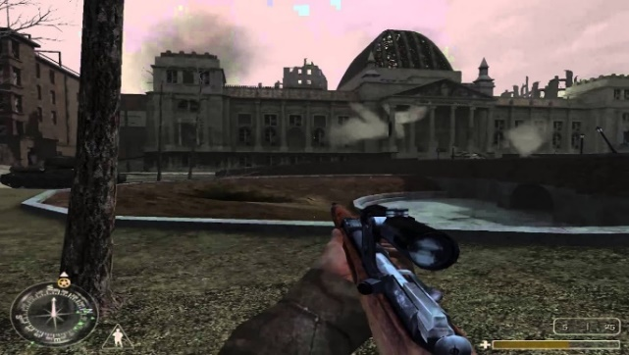 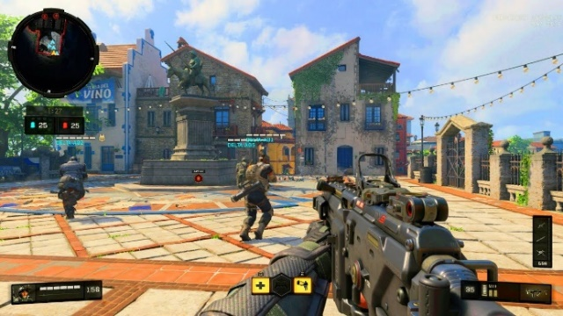

Figure 2. First Call of Duty vs. Newest Call of Duty: Growth of Technology in Visuals

In the Merriam-Webster Dictionary, virtual reality is defined as an artificial environment which is experienced through sensory stimuli (such as sights and sounds) provided by a computer and in which one’s actions partially determine what happens in the environment. From this definition, one can tell that VR offers something that no 3-D game on a computer screen can offer, and that is true immersion. It is because of these immersive capabilities that virtual reality has proven to be an effective method in teaching and providing experience for users in situations that would not normally be easily accessible or reproduced. For example, VR is being used in sports to improve certain aspects of players’ games, such as situational awareness or correction in body mechanics. A specific example comes from a study that had shown that football players were able to shave off a second of their decision making in accordance to a defensive coverage by simulating these situations and testing them on how to handle it. Another example is of Kelly Oubre Jr., a player for the Washington Wizards in the NBA. "I really saw a difference in my jump shot and free throws," says 20-year-old wing Kelly Oubre, who grew up playing "Call of Duty" and is used to wearing a headset. "I could see my mechanics, what I needed to do right." Oubre's true shooting percentage is up this year, from 50.7 to 53.4.[2] This technology is literally changing people’s careers for the better, so applying it to education for engineers is most definitely worth it.

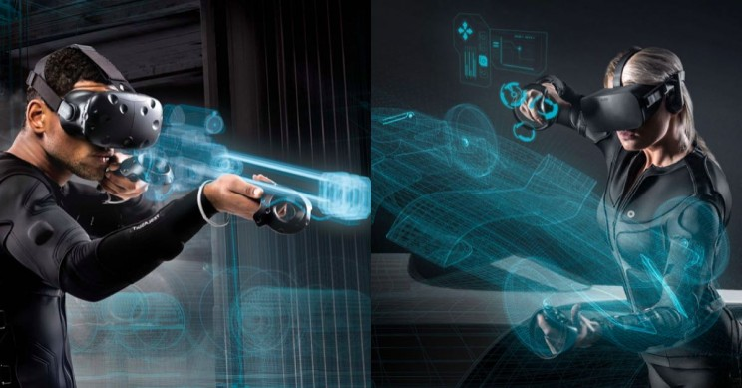

Figure 3. Versatility in Implementation of Virtual Reality

It is obvious that a combination of education, gaming, and virtual reality can provide a powerful learning tool for students if done correctly. While school subjects being the main part of a game does not sound like the most enticing idea, using the concepts of game-based learning correctly and productively could prove that to be false. Combining different gaming elements like action, shooting, puzzles, and the creative implementation of visual and sound effects with educational topics can create an experience where the player is having as much fun as a noneducational game while learning at the same time. Games provide a sense of competition that could drive students to try harder to learn subjects so they can succeed in the game, in turn, leading to success in the classroom. This is a learning tool that needs to be taken seriously and given a chance in schools or at home today.

Figure 4. Illustration of the different elements game--based learning incorporates

## Objective

The objective of this project is to develop an effective game-based, virtual reality learning tool for electrical engineering students.

## Design Requirements

1. Educate and entertain through the immersive features of VR gaming.
2. Completable within 20 minutes
3. Cover 3 subjects in the Electrical Engineering field: DC Circuits, AC Circuits, and Digital Circuits.

## Design Constraints

1. The game will be developed for the HTC Vive.

2. The game must be playable within the minimum PC hardware and space requirements provided by HTC:

* Computer:
* GPU: Nvidia GeForce GTX 970, AMD Radeon R9 290 equivalent or better  
  CPU: Intel i5-4590, AMD FX 8350 equivalent or better  
  RAM: 4 GB or more  
  Video Output: HDMI 1.4, DisplayPort 1.2 or newer  
  USB Port: 1x USB 2.0 or better port  
  Operating System: Windows 7 SP1, Windows 8.1 or later, Windows 10

**Play area:** 2m x 1.5m (6ft. 6in. x 5 ft.

## Design Method

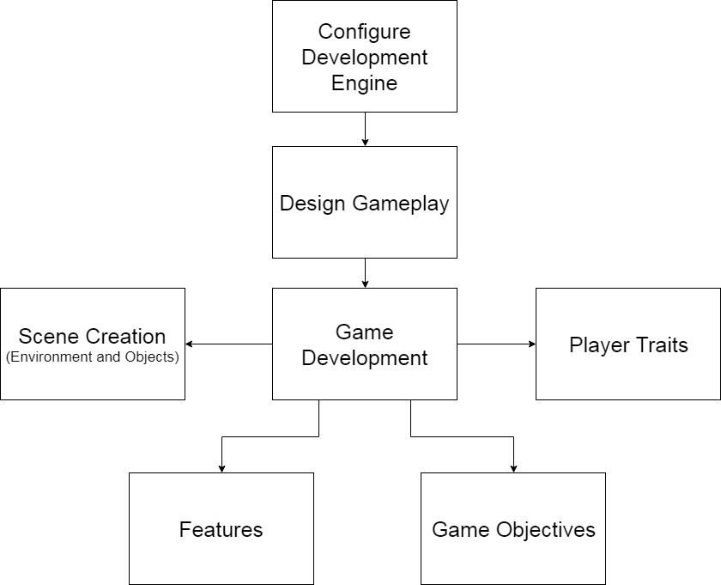

Figure 5. Flow diagram displaying the design approach

1. Implementation Plan

*This was a solo project designed by Tyler Gantz

## Tasks

* Task 1. Game Development Engine Configuration
  + Subtask 1. Unity vs. Unreal Engine
  + Subtask 2. Configure for development
* Task 2. Design Gameplay
  + Subtask 1. Scripting the game
  + Subtask 2. Create, or source required components to build the game
* Task 3. Development: Scene Development
  + Subtask 1. SteamVR Player Prefab
  + Subtask 2. In-Game Environment
  + Subtask 3. Multiple Choice Question Screens
  + Subtask 4. Keys
  + Subtask 5. Circuit Components
  + Subtask 6. Energy Shields
* Task 4. Development: Player Traits
  + Subtask 1. Health
  + Subtask 2. Ammo
* Task 5. Development: Features
  + Subtask 1. Heads-Up Display (HUD)
  + Subtask 2. Multiple Choice Question System
  + Subtask 3. Draw Mode
  + Subtask 4. Gun system
  + Subtask 5. Enemies
  + Subtask 6. Audio and Visual effects
* Task 6. Development: Game Objectives
  + Subtask 1. Puzzle 1
  + Subtask 2. Enemy encounter 1
  + Subtask 3. Circuit Design 1
  + Subtask 4. Puzzle 2
  + Subtask 5. Circuit Design 2/Enemy Encounter 2

## Timeline/Milestones/Delivery Plan

|  |  |  |
| --- | --- | --- |
| **Time** | **Task** | **Comments** |
| **Semester 1**  **Week 4**  **To**  **Week 8** | Task 1 | Required weeks of deciding on a game engine and configuring Unity after choosing. Provided a smooth transition into developing the game. |
| **Week 4**  **To**  **Week 8** | Task 2 | Designed the gameplay, including setting and objectives |
| **Week 8 to Week 15** | Task 3  Subtask 1 and 2 | Began development on the game. Designed the majority of scene objects before any programming was done. |
| **Week 15 to**  **Week 22** | Task 3 continued Subtask 3 | Designed and developed puzzles, enemies, |

Figure 6. Project Timeline

1. Implementation

## Implementation of Task 1. Game Development Engine Configuration

**Subtask 1. Unity vs. Unreal Engine**

The first task of the project required choosing a game engine to work with. The two options at hand were Unity, and Unreal. Some research was done to find what obstacles and details would be presented with either one. Both engines possess a learning curve, but navigating through that curve is different for each engine. From a programming standpoint, Unity games are programmed using C# scripts, while Unreal uses C++. The key difference is that Unity has been available to the public since 2011, while Unreal has only been free and easily attainable for anyone outside of a professional setting since 2015. It is because of this fact that Unity help and information is readily available in books or online from a quick Google search.

Figure 7. Unity Logo

For Unreal Engine, it was widely considered the more powerful engine. This is the engine that some of the largest development companies use because it can achieve higher heights than Unity can visually. One would think that it was an obvious choice to go with the more powerful engine, however, one must also consider the documentation available for Unreal. The level at which the game runs from a functionality standpoint is more important than any level of visual quality. Also, it is well documented that Unreal Engine-powered games require more computing power, which directly conflicts with the minimum PC requirements constraint placed on the project. Considering all the information gathered, Unity was chosen to develop the game.

Figure 8. Unreal Engine Logo

**Subtask 2. Configure Unity for Development**

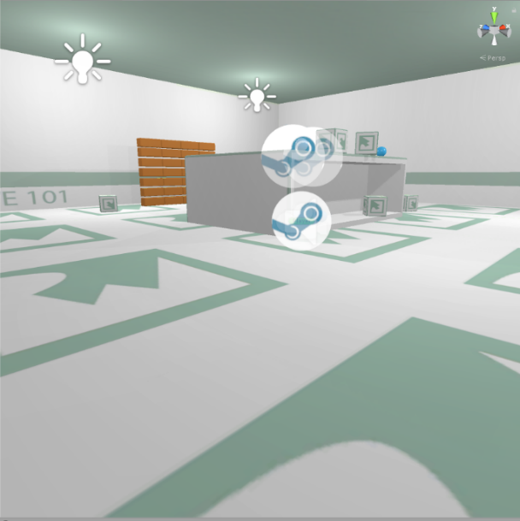Once Unity was chosen, it needed to be configured for development. In order to configure the engine, tutorials were completed on scene building. The tutorials provided a workshop for object creation and script writing. Once the tutorials were completed, a pre-built scene was found online, which could be used to test the SteamVR Plugin. The SteamVR plugin is an asset pack found on the Unity Asset Store that provides a multitude of scripts and prefabs that are necessary for the basic functions of the HTC Vive. Scripts for object interaction, like picking up and throwing, and the teleportation feature are examples of the most useful assets in the pack. Applying these scripts to the prebuilt scene allowed for coding-focused experimentation more than taking the time to have to design a functioning scene. This is where an understanding of how the HTC Vive detects inputs through code was formed, which was vital for developing the game.

Figure 9. Scene used during engine configuration

## Implementation of Task 2. Design Gameplay

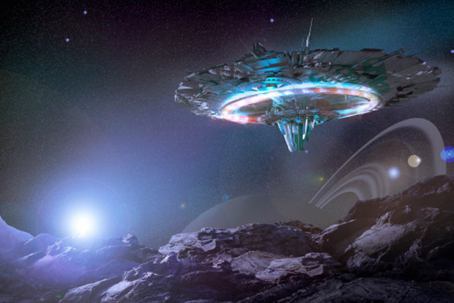**Subtask 1. Scripting the Game**

Task 2 was all about designing the game from a creativity standpoint. Throughout the early configuration stages of the project, settings and suitable objectives within a certain setting were brainstormed. After a few weeks of weighing out options, the setting was chosen to be an alien space in outer space. The overarching objective was to escape the alien spaceship. The player is going to be put to the test through multiple choice questions (with an electrical engineering focus), physical objectives, and puzzles. The game is supposed to function like an escape room, which is an activity that has become popular over the recent years where groups enter a room full of puzzles, brainteasers, and scavenger hunts. The group has to solve these within a time limit to successfully complete the challenge. This is the concept that the game will take on. It provides a fun, interactive environment that requires the player to think through each step.

Figure 10. Picture supporting the proposed alien spaceship setting

The diagram below provides a detailed layout of how the game will flow.

Figure 11. Gameplay flow diagram

**Subtask 2. Create or Source the Required Components to Build the Game**

In order to create this setting with its objectives, in-game objects needed to either be made or sourced. Unity allows for objects of basic 3-D shapes to be created and placed throughout the game in any kind of orientation desired. From there, you can add components, such as colliders, rigid bodies, scripts, etc. to the object, providing the user with a lot of customization. For this project, the structural design of each of the rooms, all circuit components, and over 90% of the scripts will be self-made using Unity’s built object creation or 3rd party software.

However, in order to make the highest quality game objects, skills in fields like animating and 3-D modeling are necessary. Unity presents a way for programmers to get by without possessing high-level skills in these disciplines by providing the Unity Asset Store (UAS). The UAS consists of thousands of objects, materials, sounds, animations, etc. that have been made by other users who may have more experience working with these assets. Unity developers can then purchase these assets to then use in their own games. It breaks down a wall that would undoubtedly hold back programmers from developing great games. Here is a list of some of the assets purchased for this project, with a short description of how they are implemented:

* Vast Outer Space Skybox – The skybox, or shell, to the environment that provides the visual sensation of being in outer space
* Sci-fi Styled Modular Pack – A collection of assets themed around a futuristic setting. The majority of the objects used for building the setting were found in this pack, like the battery objects, the floor pieces, windows and doors.
* Force Field Effects – A collection of objects that take on a force field effect that will be used to block off objects from the player.
* Futuristic Weapon Pack – A set of high detailed weapons to be used in the game as the primary weapons for players in objectives that involve shooting.
* CRT LCD Shader – An asset that provides a screen in which you can attach a video player. Mostly provides a level detail to the game because at a close glance, the player can see lines of pixels as if he/she were looking at a real LCD screen.

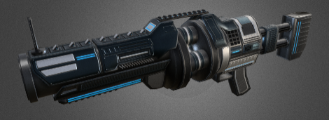

Figure 12. Examples of some assets found in the game

## Implementation of Task 3. Scene Development

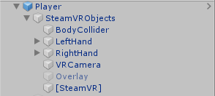**Subtask 1. SteamVR Player Prefab**

The first object that needs to be mentioned in the scene is the SteamVR player prefab. This prefab includes object, object components, and scripts every developer needs to get started on a VR game. The screenshot on the right displays the most important objects found in the prefab.

The body collider object contains the components that essentially act as the mid-section of the player in the game. While there is no visible body object, there is a capsule collider component attached to this object that is oriented as if there was a body on the player. This is a necessary component to ensure the player interacts with the other objects in the scene correctly. For example, if this component did not exist, an attacking enemy would have no way of contacting the player. This object also contains a small but important script that establishes the relationship between the height of the capsule collider and the “head” of the player. It is what makes the perception of the player from eyesight to the ground feel realistic in-game.

Figure 13. SteamVR Objects

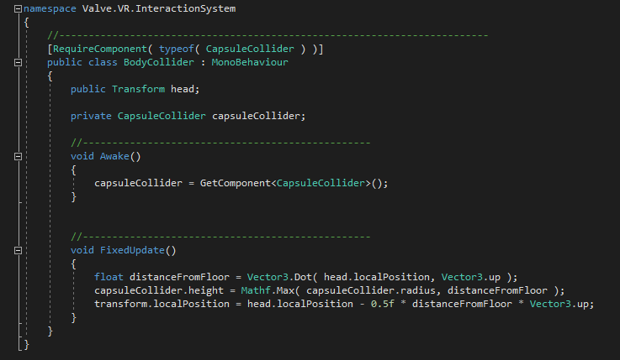

Figure 14. Code for the body collider object script

Next up on the list are the hands of the player. The left and right hands each contain colliders just like the body object, along with some of the most vital scripts for object interaction in-game. By default, the colliders attached to the hands are just spherical colliders placed near the visible hands the player can see in-game. However, 2 modifications were made to the colliders. The first was that the sphere colliders needed to be move and resized so they fit the hand models in-game better. It caused problems when working with interactable objects because the player had to reach too far into the objects to interact with them. The second modification was adding a small capsule collider to more realistically fit the hand models. As seen in the accompanying picture of the hand models, the pointer finger sticks out while the rest of the fingers create a fist. For some of the interactions where precisely contacting objects was unavoidable, it was essential that a collider was added to the pointer finger to add a precision collider to avoid unwanted collisions with the larger-sized sphere collider. Specific examples of scenarios like this will be pointed out later in the report.

Figure 15. Picture of the in-game hand models

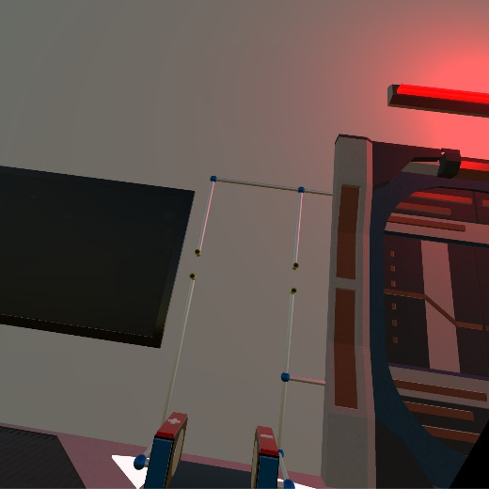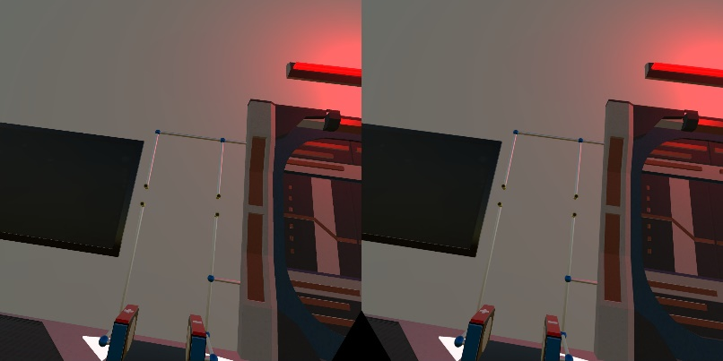The VRCamera object is what provides the view from the HTC Vive headset. The trait that sets it apart from a typical 3-D game camera is that it has controlled values for stereo separation and stereo convergence. Stereo separation in relation to VR is the distance between each eye. Each eye perceives the world slightly differently due to them being separated from each other, however, the brain perceives the view as one single image. This setting is what creates the immersive feeling in VR, where it feels like your in a new world, rather than looking at a screen inside a headset. It automatically sets the field of view so that the perception is similar to the real world. This perception of seeing one single picture rather than two separate pictures is the result of stereoconvergence. The values for each of these are fine-tuned to create the most realistic view possible for the player and to help avoid eye-strain and motion sickness.

Figure 16. Picture in each lens vs. Perceived image

The [SteamVR] object contains simple but useful scripts. The first script initializes SteamVR on start-up. That ensures SteamVR will open so the player does not have to worry about initializing it themselves and helps avoid communication errors with the equipment. The other script initializes action sets created for the controllers in the game. This is what provides the game the specific input instructions mapped out by the SteamVR plugin for each of the controllers. It is vital in ensuring the game runs correctly with the hardware

**Subtask 2. In-Game Environment**

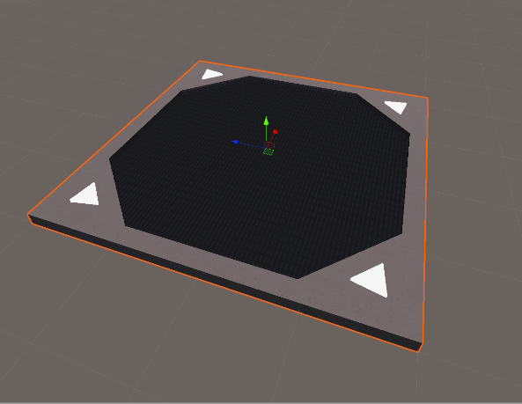After the idea to create an action escape room game came to mind, it was time to create and build the room itself. A few key points that needed to be adhered to was a lot of space was needed so all features and objectives could fit, it needed to take on a futuristic setting, and it needed to include structures that could be used in fights against enemies. The Sci-Fi Styled Modular Pack (SFSMP) was the go-to asset pack for building the room as it seemed to something to fulfill every need. This was made possible with detailed floor pieces with built-in lights and a lattice cover that scaled to larger sizes nicely. The 1.5-times scaled objects were placed in a 5x5 grid. The room ended up being 225 sq. units in size, which is perceived to be quite large when the player enters the VR world. It was a great start to creating the room.

Figure 17. Picture of a single floor piece

Next, surrounding vertical objects were placed, like walls, doors, and windows. The walls are made up of several thin, but tall and wide cubes made directly in the Unity editor. Doors were placed on the front and far end of the room, one designated to be the door the player was theoretically entered from, while the door on the far end is the one the player needs to open to escape. In each of the 4 corners and in the center of the left and right walls, windows were placed so the player can see into outer space. The corner windows were made out of 3 corner glass panels found in the SFSMP stack on top of each other with some overlap for a decorative effect. The windows in the side walls were created by rotating the big windows found in the same asset pack 90 degrees in the z-direction and then elongating them to match the height of the walls. Once again, each of the objects scaled nicely, which created good visuals to the primitive version of the room.

As previously mentioned, structures needed to be placed in the room that could provide cover during the action sequences in the game. The solution to this was placing 4 pillars, with one in each of the 4 quadrants of the room. The columns are aesthetically pleasing and also block sightlines, which can provide the player safety in enemy fights.

The room obviously needed some decorative elements as well. One of the more impressive looking objects in the SFSMP was the projector. The base object of it looks great, but the projection particle system added a futuristic flair to it. A giant projector was placed in the center of the ceiling, which will act as the system in which the character receives items from allies. The lights included in the asset pack were also great for decoration. There are multiple styles included in the pack. Lights were applied to the left and right side of each pillar, along with on top of the doors.

An overview of the complete room is shown below.

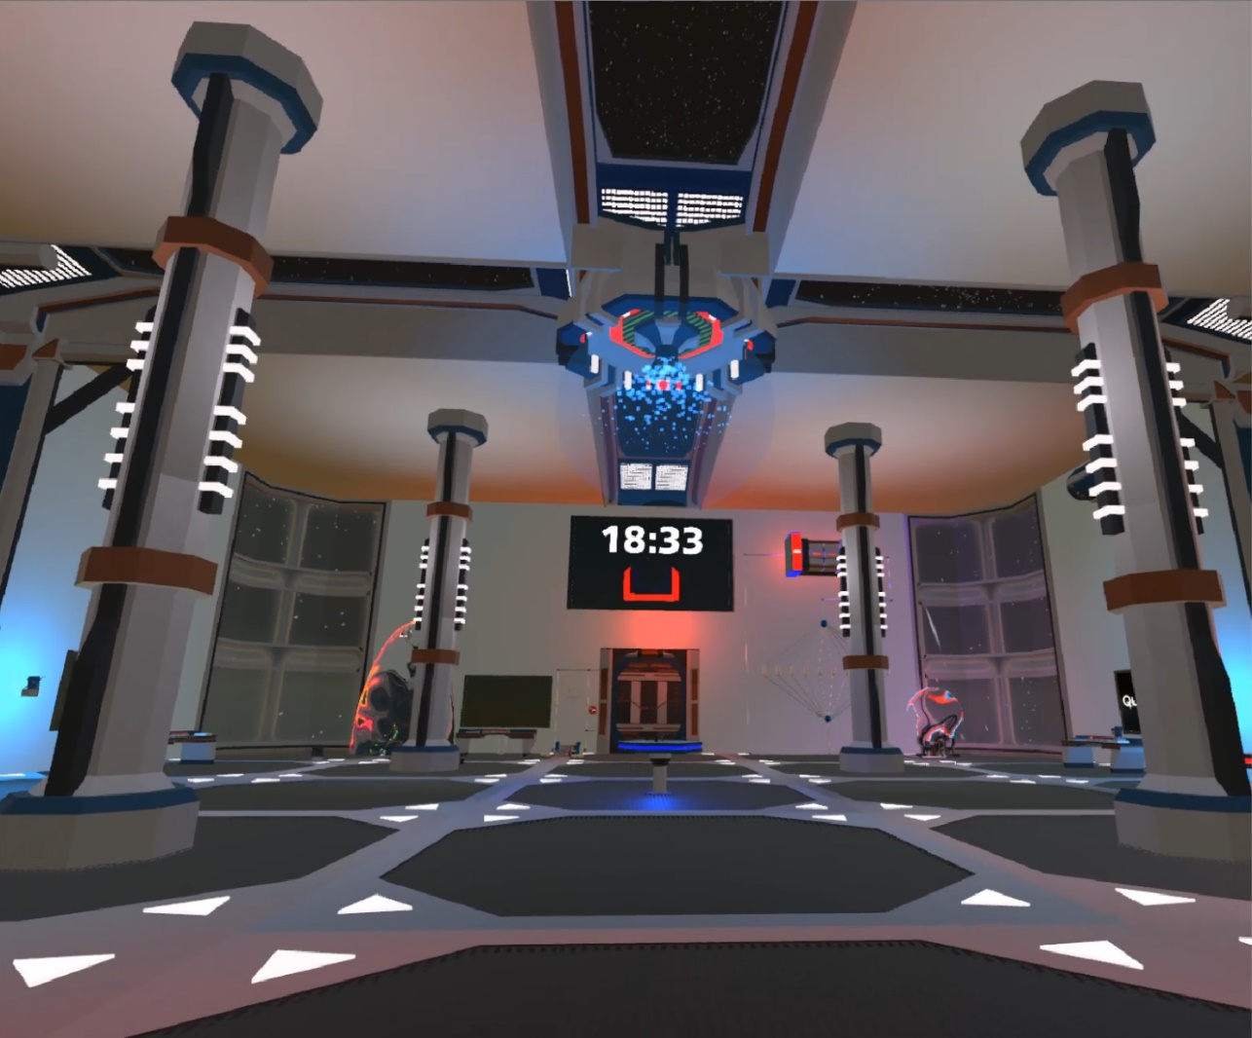

Figure 18. Overview of the entire room

**Subtask 3. Multiple Choice Question Screens**

A repeating objective the player will face in the game are multiple choice questions. In order to create a functional multiple choice question machine, 2 problems needed to be solved: finding a way to successfully display the question and answer choices, and how to allow the player to input an answer.

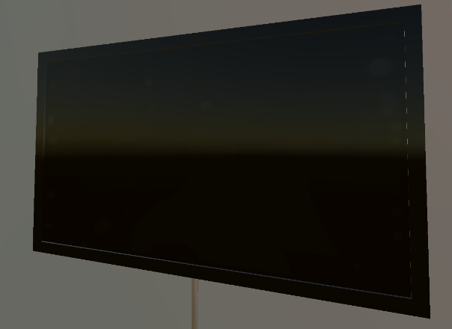There are multiple ways of displaying text and images in Unity. However, choosing a clean, aesthetically pleasing way to present the questions was the priority. This is where the LCD Widescreen asset came into play. This asset provides an object with an attached shader that is essentially an in-game LCD flat screen TV. Images or videos can be attached to any object as a material in Unity. However, what sets this object apart is the aforementioned shader. The shader on the object creates visible “pixels”, just like one would see if he were to look up close to a real LCD screen. To make each screen look more like a TV, some 3-D cubes were created and elongated and set with a glossy material to act as the trim around the screen.

Figure 19. LCD Screen object

The next step was to create and place all of the on-screen objects found on the multiple choice screens. Unity offers multiple user-interface (UI) objects, a few of which were perfect for this task. The first step was to attach an object called a canvas to the LCD screen object. A canvas is essentially an invisible 2-D base to any UI-based object. The canvas was resized so it fit the shape of the LCD screen. Now that the canvas was placed, the multiple choice images and text could be set up. Each question has 3 screens to transition through, the cover screen that shows the question number, the main question screen, and the correct/incorrect screen. An empty parent object was created for each screen. Then, a UI image object was placed on each and resized to fit the canvas. Each UI image was recolored to black. After each screen was established, the text objects could be placed. One of the key goals of creating these screens was to allow scripts to control what exactly is displayed on each screen. So, at the time of creation, the text objects just included some generic text describing what it will be used for. The cover screen just displays the question number. The main question screen displays the question text, the question timer, and the answer choices. The answer choices use UI button objects for the visual effects, but the script will just change the text inside the button. The correct/incorrect screen just displays whether the player got the question right or wrong. The programming of this feature will be explained later in the report.

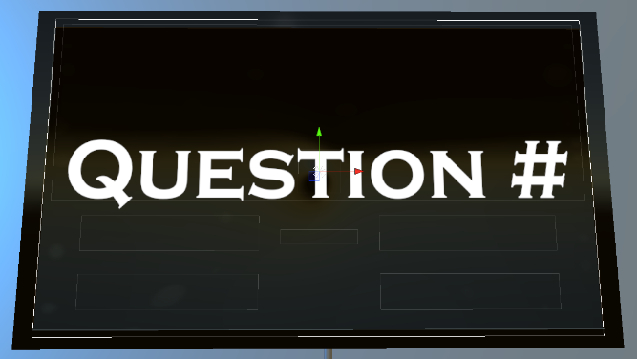 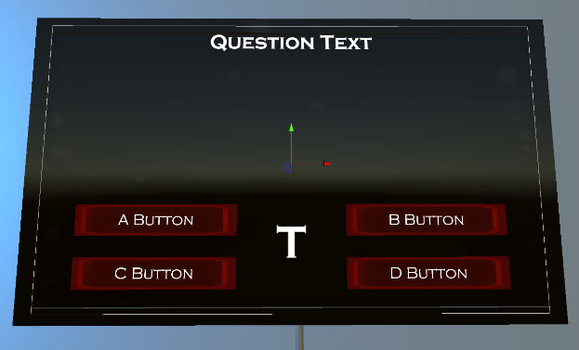

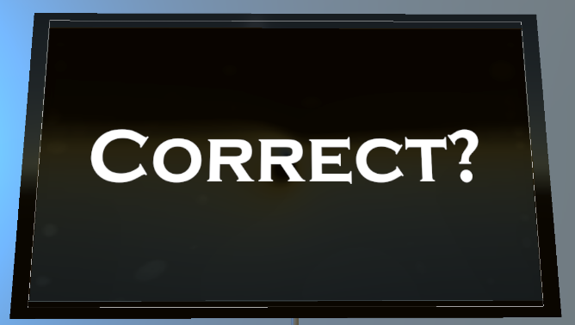

Figure 20. Cover screen, question screen, and correct screen.

Now that all of the display objects were created, a solution for taking input from the players was needed. The original idea for this was making the question screen a touch screen. However, the screen would’ve had to be much smaller for the player to get close enough to touch it, while also being able to read it without having to move back from it. We found an asset pack in the store called “Simple Animated 3-D Buttons” that provided just what we needed. Just like the title of the pack states, it provided buttons in 2 different shapes and sizes. However, at first, the buttons only recognized mouse clicks since they were designated for non-VR, 3-D games. After looking into the objects built-in code, all that was needed was changing the *OnClick()* function to the *OnTriggerEnter()* function. Now, when the player comes in contact with the buttons collider, it will run everything inside the function, rather than having to click on it. After getting the buttons to function correctly, they were placed on a table (provided in the SFSMP). One large square button was placed that will be used for starting the question, and then 4 smaller, round

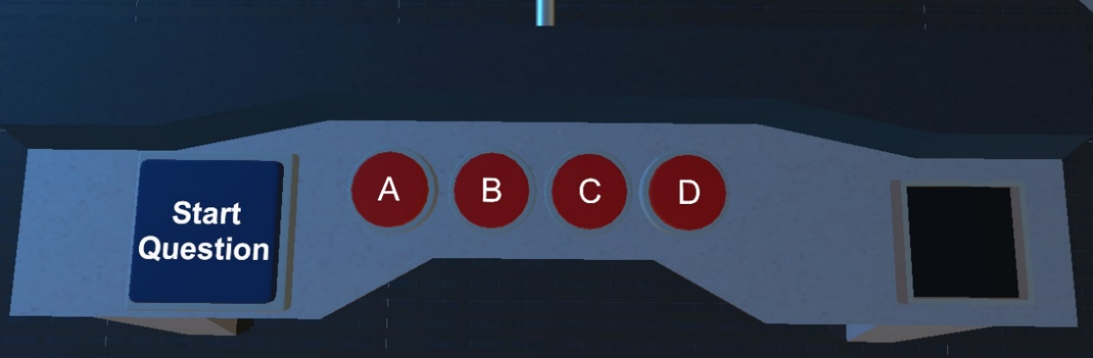buttons were placed, one for each answer choice. Like stated earlier, the programming portion of this feature will be described later.

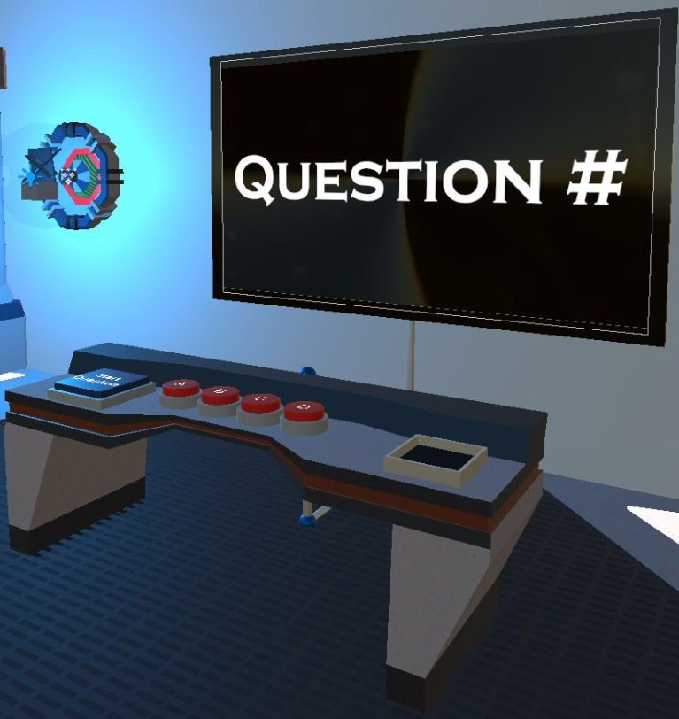

Figure 21. View of Multiple-Choice Question Buttons, and full-screen object view

**Subtask 4. Keys**

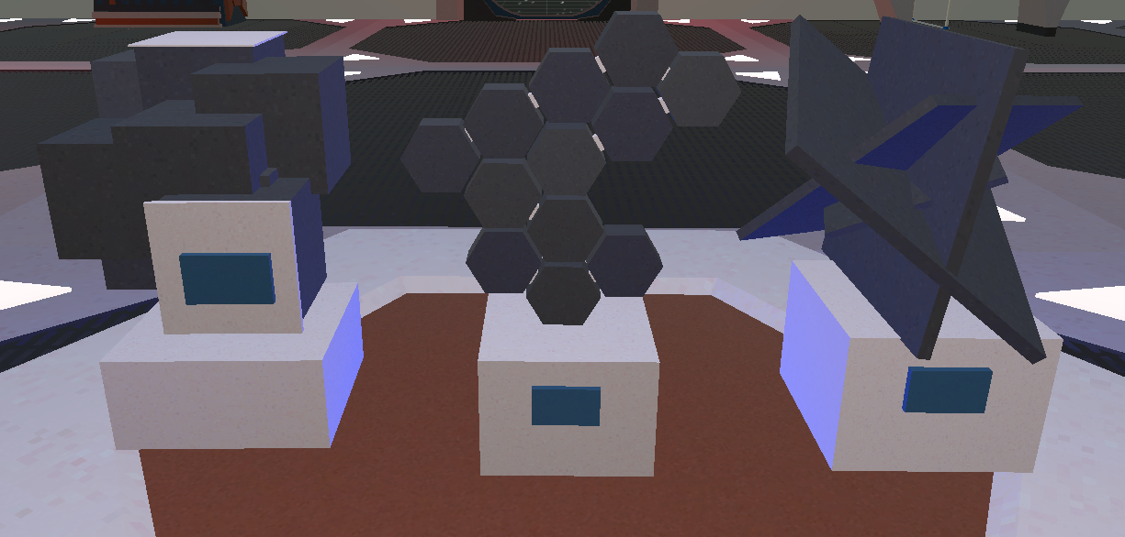

Figure 22. Picture of some of the keys found in the game

In order to create a better sense of progression in the game, we decided to establish a set of items players need to retrieve from completing objectives. After going through some of the asset packs already in the game, we found these artifacts in the SFSMP, and they were a great solution for the issue. A few objects had to be built into the scene in order to correctly implement this key system. The main function of the keys is to activate a designated multiple choice question. So, we had to create a way for players to know which key goes with which question, and a slot in which the players can place the key to activate the question.

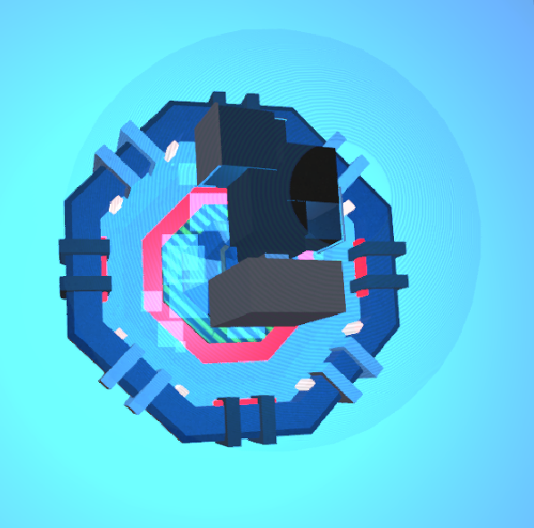There were multiple ways that we could have gone with displaying the correct keys for each question. For example, the original idea was just to place a picture of the correct key on the screen of each multiple choice question. However, since the game has a futuristic setting, we decided to create a more technologically advanced object to achieve this. Next, to each multiple choice question screen, the player will find what appears to be a hologram version of a key. The key found inside that hologram is the key designated for that question. The hologram key has no collider attached to it, so it is not player-interactable. However, it does have a rigid body and script attached to it so some visual effects could be added to it. The script creates a constant rotational velocity and vertical sinusoidal movement pattern on the hologram, providing a “floaty” visual.

Figure 23. Hologram found next to Question 1

Next, we had to add a key slot to the multiple choice screen set up. These were built using 3-D cubes in the Unity editor. 4 rectangular blocks were oriented into a square shape large enough so that the base of each key will fit. Then, a cube was placed at the base of the slot to provide a flat surface for the key to sit on. This base cube was the most important piece because it is the object the script will be attached to detect if the correct key is inserted. Before the script was written, an extra box collider was attached to the base cube. This collider was moved above the base and resized to about the shape of the inside of the key slot. It was then set as a trigger, so it will not actually collide with anything, however, it will track if something is inside of it. Now that the trigger was set, a script could be written, checking for an object with the correct tag to enter the trigger collider. If all conditions are met, a bool value in the multiple choice script is set to true. That script will be discussed in the multiple choice feature section later. Screenshots of 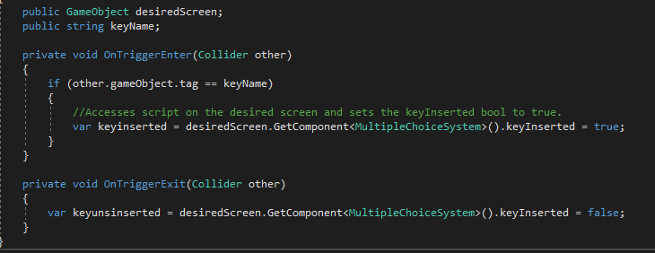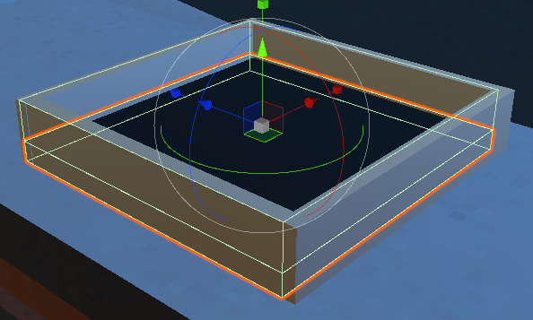the key slot with highlighted colliders and the code for the key slot are shown below.

Figure 24. Multiple Choice Key Slot and Associated Code

**Subtask 5. Circuit Components**

One of the most important topics in electrical engineering education is circuit design. Understanding how to correctly build circuits under certain conditions is essentially the practical application of everything learned in school. It is because of this that we knew we had to put circuit design objectives in the game. In order to create these objects, we obviously needed to build the circuit components. Since this game was designed mostly as reinforcement to early electrical engineering education, the objectives were mostly centered around basic DC circuits. Therefore, the objects needed were batteries, resistors, and wiring.

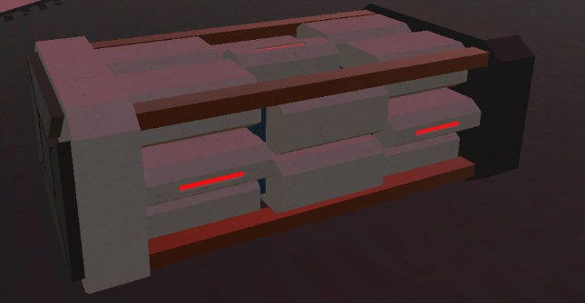Thanks to the SFSMP, finding a good battery model was rather simple. The pack contains 3 different batteries: small, medium, and large. However, the default size of all of the models was quite large. We ended up choosing the medium battery, but scaled it down to x = 0.1, and y = z = 0.15. Now, we had a solid battery model that made sense in terms of size and fit the scene stylistically.

Figure 25. Battery used for circuit design objectives

Next, we had to make resistors. The resistor models were made completely from scratch using objects and materials in the Unity editor. The resistors can be broken down into 3 parts, the main resistor capsule, the wires, and the colored bands (all of which were placed in a parent object). The main piece of the resistor was created using a capsule object in the Unity 3-D editor. It was resized to x = z = 0.12, and y = 0.2, leaving to be much larger than a realistic resistor, but it would have been impractical and hard to work with if it were that small. Next, the wires on each end were created using a cylinder object, and resized to x = z = 0.03, and y = 0.06. Since they had to protrude down on both ends of the resistor capsule, they were moved to position x = 0.15 and -0.15, and both at y = 0.93. The final part of the resistors were the colored bands. The resistors are 4 band resistors, so the bands represent the first digit, the second digit, the multiplier, and the tolerance of the resistor. They were created by altering 3-D sphere scale values into numbers that would essentially create flat disk-shaped objects. Those scale values were x = 0.02, y = z = 0.125. Then, each band was placed in realistic positions on the resistor capsule. All of which were placed at y = 1, but then spread out along the x-axis at -0.109, -0.078, - 0.046, and 0.096. Now that all pieces of the resistor were placed, materials could be assigned to each. A glossy, tan colored material was placed on the capsule to mock a real resistor's color. A silver metallic material was attached to the wires on each end. For the bands, a glowing, emissive material was made for each possible band color. These materials could be placed as needed on each band depending on the desired resistance.

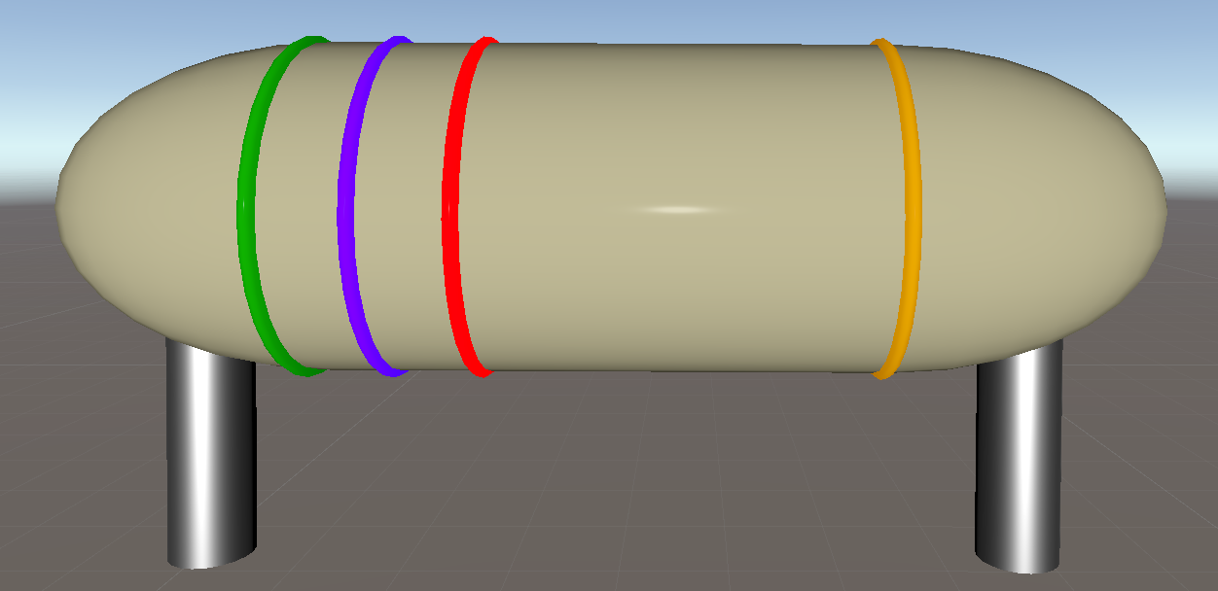

Figure 26. A 5700 Ohm Resistor

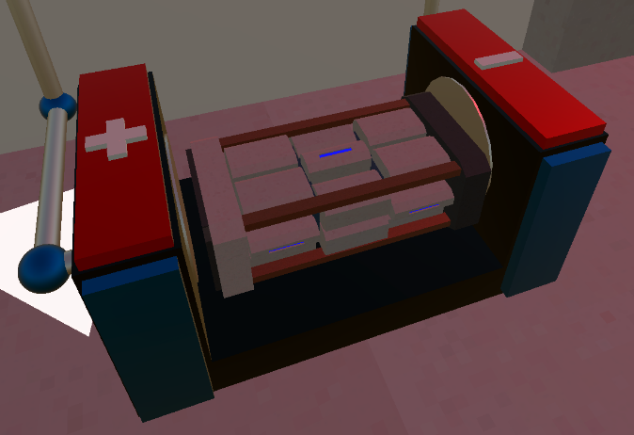Now that the components were created, the circuits themselves needed to be built. The circuit objects can be broken down into 3 main parts: the battery port, resistor ports, and the wiring. The battery port consists of 3 rectangular shaped cube objects, oriented in a U-shape with the base wide enough to hold a battery. Then, on both the left and right sides of the battery port, blue cube objects protrude out the front, while red cubes protrude out the top to give the object a visually pleasing design. Just like any battery port, the positive and negative terminals needed to be denoted. Once again, using cube-shaped objects, a positive and negative sign were created and attached to the top of each side of the battery port. Wide, but short metallic colored cylinders were placed on the inside of each side of the port to appear as the conductive materials of the port.

Figure 27. Battery port

The resistor ports and wiring are very similar in terms of their base objects. The resistor ports were created using 2 concentric cylinder objects. The outer cylinder objects had a metallic gold material attached, while the inner cylinder had a matte black material, providing the visual of an open cylinder. Unlike typical 3-D modeling software, protruding cuts in objects cannot be done in Unity, which is why this method was chosen. Two of these objects were created at the right distance from each other so the resistor wires can sit in the ports correctly. The wiring was also created using cylinder objects. However, these cylinders have a silver material attached to them, and each piece varied in length depending on the need. A description of the orientation of the wires will be described for each specific circuit when they appear in the report.

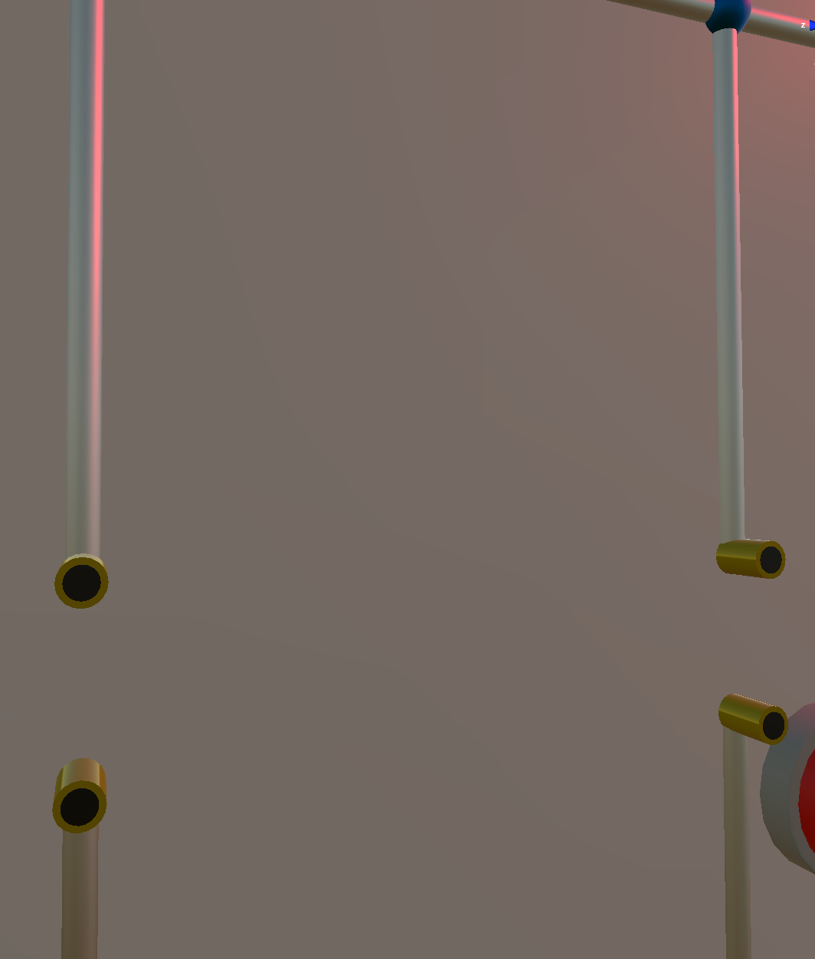

Figure 28. Example of the wiring and resistor ports

**Subtask 6. Energy Shields**

Throughout the game, the player will face certain challenges where he/she has to complete an objective to gain access to certain objects. This was an idea for game objectives since the beginning of development, however, deciding how to implement the idea creatively was the difficult part. Since the game takes place in an alien ship, a futuristic, high-tech solution would be the best fit. From past experiences playing futuristic games, a common way to block areas or objects from players was by using some sort of energy shield or barrier. It at the very least blocked access, however, in many instances, it also damaged players. This is exactly what was needed for this game. After searching on the asset store, the “Force Field Effect” pack was found. This asset pack provided force field objects of many different shapes and sizes that could be used to deny access to the players unless they want to take damage. Each force field has a pulsating effect that was created using a particle system. A particle system is a component that can be attached to any object to create a flow of particles, along with a multitude of options to fine-tune the visual effects of it. These energy shields utilized the particle system very well, which made them perfect for the game.

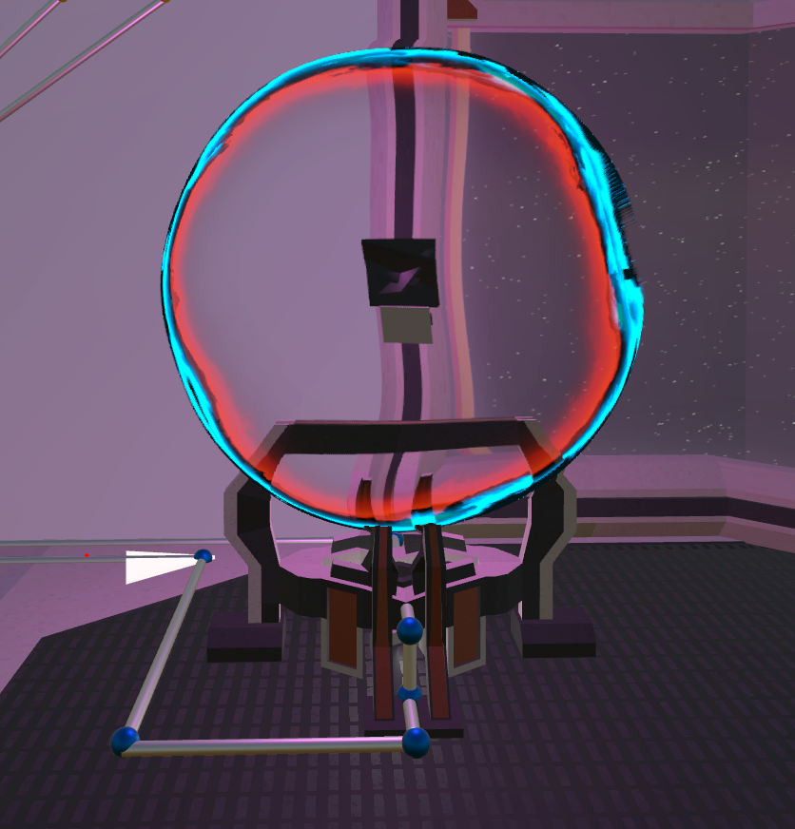 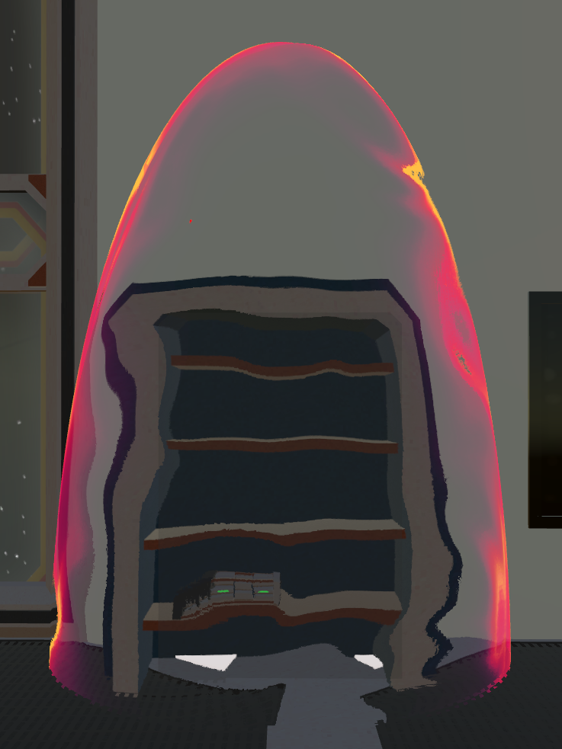

Figure 29. Energy shield examples

## Implementation of Task 4. Player Traits

In order to create a good balance between difficulty and fun, certain abilities and limitations need to be placed on the player. These traits were decided early on in development so decisions could be made around what the player can do. Firstly, just like many games, the player starts with 100 health points. Various in-game interactions will either give or take health from the player. The player health was established by writing a script and creating a variable called *playerHealth.* A parameter was placed on the health value, limiting it to a maximum of 100. Establishing this

1. Conclusion.

At the conclusion of the first semester working on this project, I have learned a lot about the design process in game development. The main issue I have encountered is not having a well-defined design method in place. For the second semester, I will be sure to have a stronger approach for laying out objectives, so I can achieve the goals faster and more efficiently.

In terms of the technical information I have gained, I learned just about everything about C# programming that I know from this project. This is providing me with a great foundation in object-based programming that can be used in many programming professions. I’ve gained more from this project so far than most classes throughout my entire time in the Electric Engineering program here at UMES. Overall, this project has undoubtedly made me a better engineer in just one semester.

Acknowledgement

Joe McGinley - one of my best friends, and a brilliant programmer who’s worked with Unity and helped me along with the way.

Appendix

1. Script: AlienCollisionDetection

using System.Collections;

using System.Collections.Generic;

using UnityEngine;

public class AlienCollisionDetection : MonoBehaviour

{

void OnCollisionEnter(Collision collision)

{

if(collision.gameObject.tag == "Pistol Bullet")

{

var pistolshothit = GetComponentInParent<RangedEnemy>().health -= 5.0f;

}

if(collision.gameObject.tag == "AR Bullet")

{

var ARShotHit = GetComponentInParent<RangedEnemy>().health -= 9.0f;

}

if(collision.gameObject.tag == "Grenade")

{

var grenadeShotHit = GetComponentInParent<RangedEnemy>().health -= 70.0f;

}

}

}

1. Script: CircuitOpensDoor

using System.Collections;

using System.Collections.Generic;

using UnityEngine;

public class CircuitOpensDoor : MonoBehaviour

{

//This is the script used to create a voltage divider circuit in the game for one of the circuit design objectives in the game.

public GameObject inputPort; //Choose either bottom or top piece of the port as your port for both input and output, I chose bottom for both input and output

public GameObject outputPort;

public GameObject batteryCase; //Choose either terminal as a distance reference, I choose the negative terminal

private Vector3 inputLocation; //Locations of the input, output, and battery port to find distance between

private Vector3 outputLocation;

private Vector3 batteryLocation;

public GameObject resistor5000; //Resistor objects with their assigned resistances

public GameObject resistor4000;

public GameObject resistor3000;

public GameObject resistor2500;

public GameObject resistor1500;

public GameObject resistor500;

public GameObject battery90; //Battery objects with their assigned voltages

public GameObject battery120;

public GameObject battery150;

private float inputResistance = 0.0f; //Float variable for resistance of the resistor plugged into the input resistor port

private float outputResistance = 0.0f; //Float variable for resistance of the resistor plugged into the output resistor port

private float inputVoltage = 0.0f; //Float variable for voltage of battery inserted into the port

public float outputVoltage = 0.0f; //Calculation of voltage using voltage divider formula

public float outputResistorPower = 0.0f; //Calulation of power dissipated by the output resistor using the power formula;

public bool inputResistorInserted = false; //Bool values tracking whether a resistor/battery is inserted into the respective ports

public bool outputResistorInserted = false;

public bool batteryInserted = false;

public Animator doorAnimator;

public Renderer doorLight;

public Material baseColor;

public Material greenEmission;

public Material[] correctCircuitLight;

public void Start()

{

inputLocation = inputPort.transform.position;

outputLocation = outputPort.transform.position;

batteryLocation = batteryCase.transform.position;

correctCircuitLight[0] = baseColor;

correctCircuitLight[1] = greenEmission;

}

public void Update()

{

//Input resistor arguments

if (Vector3.Distance(resistor5000.transform.position, inputLocation) < 0.8f)

{

inputResistorInserted = true;

inputResistance = 5000.0f;

}

else if (Vector3.Distance(resistor4000.transform.position, inputLocation) < 0.8f)

{

inputResistorInserted = true;

inputResistance = 4000.0f;

}

else if (Vector3.Distance(resistor3000.transform.position, inputLocation) < 0.8f)

{

inputResistorInserted = true;

inputResistance = 3000.0f;

}

else if (Vector3.Distance(resistor2500.transform.position, inputLocation) < 0.8f)

{

inputResistorInserted = true;

inputResistance = 2500.0f;

}

else if (Vector3.Distance(resistor1500.transform.position, inputLocation) < 0.8f)

{

inputResistorInserted = true;

inputResistance = 1500.0f;

}

else if (Vector3.Distance(resistor500.transform.position, inputLocation) < 0.8f)

{

inputResistorInserted = true;

inputResistance = 500.0f;

}

else

{

inputResistorInserted = false;

inputResistance = 0.0f;

}

//Ouptut resistor arguments

if (Vector3.Distance(resistor5000.transform.position, outputLocation) < 0.8f)

{

outputResistorInserted = true;

outputResistance = 5000.0f;

}

else if (Vector3.Distance(resistor4000.transform.position, outputLocation) < 0.8f)

{

outputResistorInserted = true;

outputResistance = 4000.0f;

}

else if (Vector3.Distance(resistor3000.transform.position, outputLocation) < 0.8f)

{

outputResistorInserted = true;

outputResistance = 3000.0f;

}

else if (Vector3.Distance(resistor2500.transform.position, outputLocation) < 0.8f)

{

outputResistorInserted = true;

outputResistance = 2500.0f;

}

else if (Vector3.Distance(resistor1500.transform.position, outputLocation) < 0.8f)

{

outputResistorInserted = true;

outputResistance = 1500.0f;

}

else if (Vector3.Distance(resistor500.transform.position, outputLocation) < 0.8f)

{

outputResistorInserted = true;

outputResistance = 500.0f;

}

else

{

outputResistorInserted = false;

outputResistance = 0.0f;

}

//Battery arguments

if (Vector3.Distance(battery90.transform.position, batteryLocation) < 0.5f)

{

batteryInserted = true;

inputVoltage = 90.0f;

}

//Voltage Divider and Power Equations

outputVoltage = (inputVoltage * outputResistance) / (inputResistance + outputResistance);

outputResistorPower = (outputVoltage * outputVoltage) / outputResistance;

if (outputVoltage == 60.0f)

{

doorLight.materials = correctCircuitLight;

if (this.gameObject.tag == "On")

{

doorAnimator.SetTrigger("character_nearby");

}

}

}

1. Script: ClockButtonPress

using System.Collections;

using System.Collections.Generic;

using UnityEngine;

using UnityEngine.UI;

public class ClockButtonPress : MonoBehaviour

{

public GameObject resistorBandChart;

public GameObject multimeter;

public GameObject Notepad;

public GameObject HUDWeaponModels;

public GameObject resBandButton;

public GameObject multimeterButton;

public GameObject notepadButton;

public bool test;

void OnTriggerEnter(Collider col)

{

if (col.gameObject.tag == "Player")

{

resistorBandChart.SetActive(false);

multimeter.SetActive(false);

Notepad.SetActive(false);

HUDWeaponModels.SetActive(true);

PressedButtonColor();

ResetOtherButtonColors();

test = true;

}

}

void PressedButtonColor()

{

var pressedColor = new Color32(255, 182, 182, 255);

var thisbuttonColor = this.gameObject.GetComponent<Image>().color;

thisbuttonColor = pressedColor;

this.gameObject.GetComponent<Image>().color = thisbuttonColor;

}

void ResetOtherButtonColors()

{

var originalbuttoncolor = new Color32(96, 9, 9, 255);

var resbandbuttcolor = resBandButton.GetComponent<Image>().color;

var multimeterbuttcolor = multimeterButton.GetComponent<Image>().color;

var notepadbuttcolor = notepadButton.GetComponent<Image>().color;

resbandbuttcolor = originalbuttoncolor;

multimeterbuttcolor = originalbuttoncolor;

notepadbuttcolor = originalbuttoncolor;

resBandButton.GetComponent<Image>().color = resbandbuttcolor;

multimeterButton.GetComponent<Image>().color = multimeterbuttcolor;

notepadButton.GetComponent<Image>().color = notepadbuttcolor;

}

1. Script for Rotating Skybox

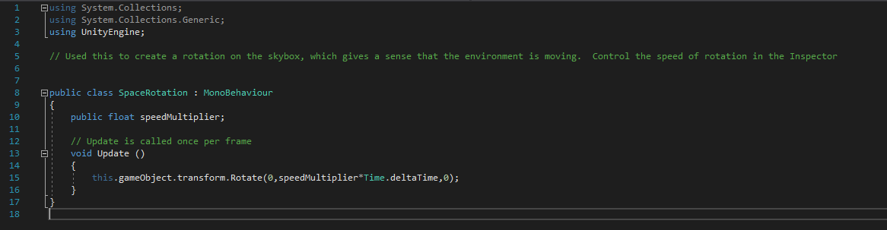

1. Script for Touch-Activated LCD Screen

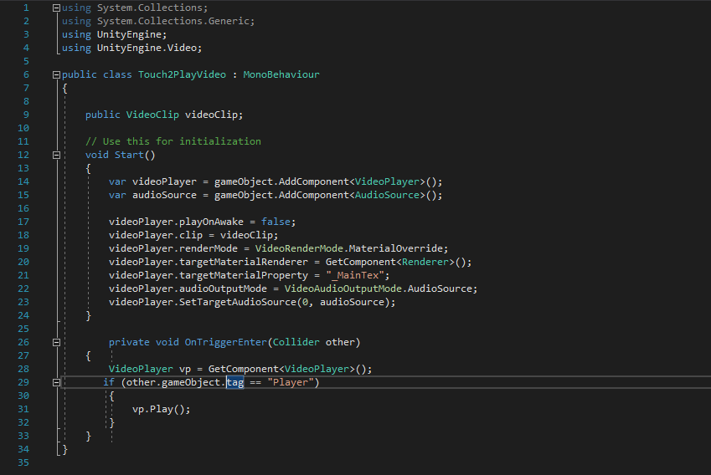

1. Script for Exploding Rounds

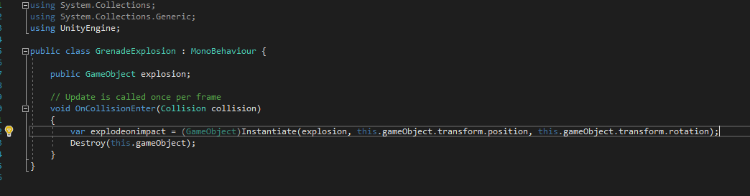

1. Script for Shooting Projectiles

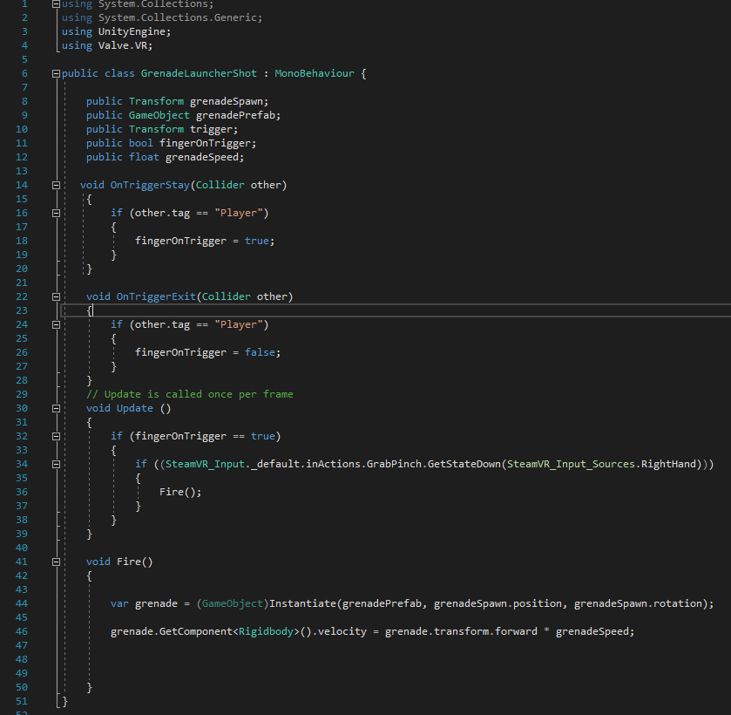

1. Script for Destructrable Generators

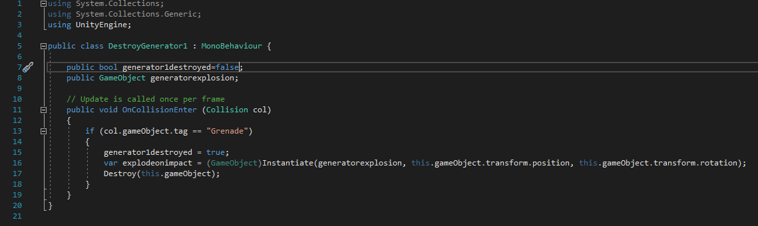

REFERENCES

[1] Teed, R. (2018, May 07). Game-Based Learning. Retrieved December 12, 2018, from https://serc.carleton.edu/introgeo/games/index.htm

[2] Haberstroh, T. (2017, February 8). Game-Based Learning. Retrieved April 10, 2019, from http://www.espn.com/nba/story/_/page/presents5/washington-wizards-virtual-reality